# Comments on the dynamics of interest rates from graph (Figure 1)

The movement of the spread of corporate bonds – also representing the yield on said bonds, tell which time periods should be examined to understand what variables are considered to influence interest rates – represented through the spread of corporate bonds.

The first significant movement in the interest rate data comes during The Great Depression from 1929 to 1939. Prior to the global recession, US interest rates – represented through the yield curve, was declining, hovering at around 6%. However, as the Great Depression manifested, the interest rate became much more volatile and peaked at roughly 11% before descending again. Interestingly, there is a smaller peak as contractionary fiscal policies were implemented in 1937 causing a lesser jump in interest rates. The yield curve then stabilizes until a period in American economic history called The Great Inflation. Both Moody’s corporate bond curves, treasury bills, and the federal fund rate see severe volatile behaviour from 1954 to 1982. There is a consensus amongst economists that the Great Inflation was caused by an excessive growth in the supply of money. The downturn and beginning of the stabilization of the interest rate comes during Ronald Reagan’s presidency from 1981 to 1989. Confidence is restored in the treasury’s bills through monetary policies and thus its interest rate decreases from a peak of 19% to 6%. The federal bills keep stabilizing as economists revaluate the role of the government and central banks following the great inflation. The new government and central bank approach focuses on maintaining a low interest rate, only sanctioning increase during economic hardship. This is seen through the increase in the federal fund leading up to and during the housing crisis of 2007 – another global recession. However, interest on corporate bonds do not spike at the same level as during The Great Depression. The relative ease of the volatility of the yield curve can be attributed to the monetary policies implemented as can be seen through the decrease in the effective federal funds rate and treasury bills. Following another global recession, the interest rate of the corporate bonds stabilizes again at around 3%-6% until the Covid-19 pandemic.

While there are several major spikes that tell what variables to focus on, there are continuous fluctuations throughout these major spikes. It can be understood that there is a continuous cycle throughout the trends of the curves known as the business cycle.

From the dynamics of the interest rate data, there are mainly 4 variables that influence the interest rate; the business cycle, the effective federal funds rate, inflation, and if there is a global recession.

# Comments on regression created

The validity of the claim made previously about global recessions, business cycles, federal fund rate, and inflation affecting the interest rate can be tested through a regression analysis. By accessing panel data from the Federal Reserve Economic Data website, one can create the necessary variables. Firstly, the spread of corporate bond yield is created by simple subtraction of the lesser rated bond from the better rated bond. This spread is the baseline for the following regression. Then, a dummy variable – a yes or no response, to whether the economy is in the housing crisis of 2007. The monetary policy variable is created from the data on the federal fund rate. A variable for inflation is created by using year-on-year changes in the Consumer Price Index. Then Lastly, for the creation of the business cycle variable, one must use data in the form of an index on industrial production, and then use the Hamilton filter to generate the cyclical component of production. The variables created have the descriptive statistics shown in Table 2 in the appendix.

From the variables created, we then run the following regression:

$${SP}_{t}=α_{0}+α_{1}y_{t}+α_{2}D2007+α_{3}{FFR}_{t}+α_{4}π_{t}+ϵ_{t}$$

Where ${SP}_{t}$ is the spread, $y_{t}$ is the business cycle at time t, $D2007$ is the dummy capturing the financial crisis of 2007, ${FFR}_{t}$ is the monetary policy at time t, $π_{t}$ is the inflation rate at time t, $ϵ_{t}$ is the error term of the regression. The regression is summarized in Table 3 in the appendix.

**Analysis of regression results**

The variable for business cycle was created using logarithmic data on industrial production. Then, through the Hamilton filter, the cycle can be extracted at a monthly interval and used for further analysis. The Hamilton filter is a levelled variable and is therefore multiplied by 100 to ensure that measurements contribute equally to the model. Firstly, it is important to note that the coefficient is negative, meaning an increase in the business cycle gives a decrease in the spread of corporate bonds. Specifically, there is a 0.35-point decrease in the business cycle model – meaning the economy is moving downwards, there will be a 0.35 basis point (bps) increase in the spread of corporate bonds. When consumers are expecting economic hardship as before a recession, investors will choose safer bonds over riskier bonds. This means the spread between AAA and BAA bonds become greater. This is also easily observable in graph [] as the corporate bond spread notably increase during well-known recessions.

The dummy variable of the global housing crisis from 2007 gives a representative correlation between the state of the economy (recession/no recession) and the spread of corporate bonds. The coefficient of the dummy variable 2007 represents the percentage change in corporate bond spread given that there is a recession there will be a 0.72 increase in spread between corporate bonds. Again, underlining that when there is economic hardship, investors prefer less risky bonds and move from AAA to BAA rated bonds. 0.72 is a rather strong relationship, yet it could be argued the value should be stronger.

Since the variable for inflation is created using logarithms, the variable is multiplied by 100 to rescale it so the interpretation of the coefficient is that of log-log. This means that a 1% increase in inflation will increase the spread of corporate bonds by 0.36 points. As a result, there is an established positive relationship between inflation and interest rates, in line with the theory. However, the relationship is not as strong as one would imagine, especially when considering The Great Inflation. It can be argued that inflation presents a slight marginal increase, meaning initial increases in inflation from its natural level are not as severe on interest rates as further increases in inflations. It can be understood that the data fails to capture the behaviour completely as the assumption of marginally increasing effects are not represented in a linear regression.

Federal Fund Rate is a representation of the monetary policies implemented and the variable shows its effect on interest rate. Theoretically, the macroeconomic policies implemented by the central bank should be directly linked to the interest rate, which would give a coefficient of almost 1.00 in the regression analysis. However, the value given from the regression is 0.047. This is due to the spread of corporate bonds being tested and so the low value show that the two bonds move together. Expecting 1.00 would be misinformed since the regression tests spread and not individual bonds. The correlation coefficient in Table 1.1 shows the almost uniform movement in corporate bonds as a response to changes in federal funds rate.

The econometric analysis is sound as the regressions are all statistically significant as the p-values come out to less than 0.01 for all variables and the regression has a proportional dependency (R squared) of 66%. There is a major discrepancy in the correlation coefficient of the variable representing monetary policy – federal funds rate, and the coefficient in the regression of the same variable against the spread in corporate bonds. As argued earlier, the low value likely comes from the interest rates on each bond moving together.

# Explanation on dynamics of spread from 2018-2022 (Figure 2)

There are two majorly distinguishable movements in the graph depicting the corporate bond spread from 2018 to the end of 2022 – the time period showing the Covid-19 pandemic. The World Health Organisation announced Covid-19 to be a pandemic in March. From February to April, the bond spread spiked from 0.83 to 1.7. As it became clear that future productivity would fall, investors chose to move from riskier bonds to less risky ones. This movement is noticeably less severe compared to the financial crash of 2007 previously analysed. The relatively lower spread during the pandemic can be attributed to banks having learnt how to determine which firms were more likely to default on their loans. However, the spike during the pandemic still shows there was a significant increase in interest rates.

The subsequent decrease in the spread show how the government can – through monetary policies and confidence boosting, decrease the impact of financial troublesome times. Through the central bank’s control of the interest rate in the short run, aimed at closing an expected negative output gap and rising inflation. Ultimately, the central bank helped restore confidence as investors are given more leeway in maintaining their loans without defaulting. At times, one could theorize the central bank would commit to forward guidance to ease the impact of the pandemic. Forward guidance in this instance would be through the central bank promising to reduce inflation to a level lower than what it considers desirable to compensate for not being able to break the liquidity trap – from not being able to have negative interest rates. Very few countries use forward guidance as a practice, and not even Australia who has this policy agreement in place for extreme situations ended up applying it during the pandemic. The monetary policies implemented by the government was sufficient to decrease the interest rate to a desirable level again as is shown from the fall in the spread following April of 2020.

Although the fluctuations can be attributed to certain actions – such as declaration of the pandemic and central bank interest rate setting, there is still many factors that contributed to the dynamics of the spread during the pandemic. Mainly, uncertainty cannot be said to have been fully restored, despite the graph being somewhat stable. It would be more correct to attribute the stability of the spread to strict monetary policies rather than investors willingly changing their investment decisions.

# Appendix

**Figure 1**

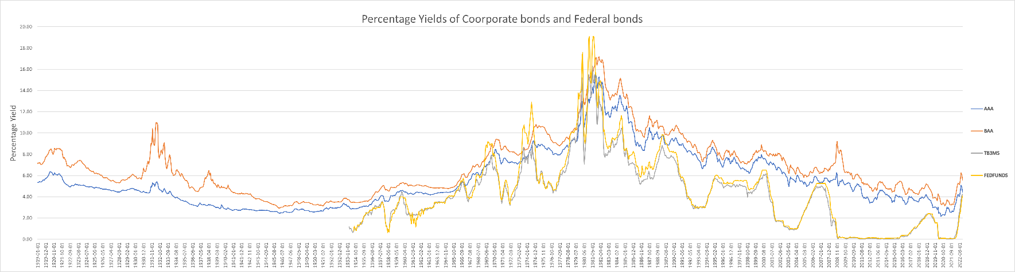

Figure - Percentage yield of AAA (blue), BAA (orange), TB3M (grey), and FEDFNDRATE (yellow)

**Figure 2**

Figure – Corporate bond spread from Jan 2018 - Dec 2022

**Figure 3**

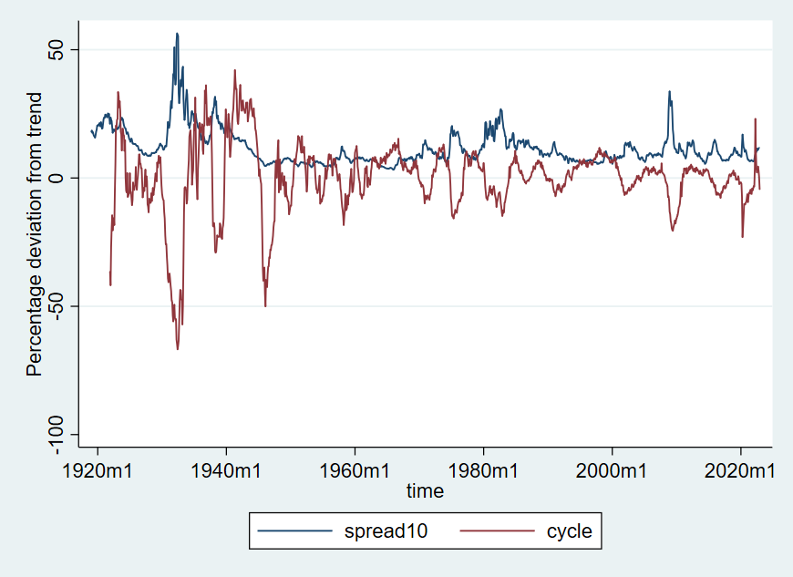

Figure – Percentage deviation from trend of rescaled corporate bond spread (blue) and business cycle (red) from 1919 to 2022

|  |  |  |  |  |  |  |
| --- | --- | --- | --- | --- | --- | --- |
| Variable | | Obs | Mean | Std. Dev. | Min | Max |
| aaa | 1248 | | 5.65 | 2.671 | 2.14 | 15.49 |
| baa | 1248 | | 6.822 | 2.835 | 2.94 | 17.18 |
| tb3ms | 828 | | 4.177 | 3.119 | .01 | 16.3 |
| fedfunds | 822 | | 4.595 | 3.618 | .05 | 19.1 |
|  | | | | | | |

**Table 1** – Descriptive statistics of AAA, BAA, 3-month treasury bills, and Federal Funds Rate.

|  |  |  |  |  |
| --- | --- | --- | --- | --- |
| Variables | aaa | baa | tb3ms | fedfunds |
| aaa | 1.000 |
| baa | 0.992 | 1.000 |
| tb3ms | 0.876 | 0.848 | 1.000 |
| fedfunds | 0.867 | 0.842 | 0.990 | 1.000 |
|  | | | | |

**Table 1.1** – Correlation coefficient across the series over entire sample (AAA, BAA, TBILL3, FEDFUND)

**Table 2** – Descriptive statistics of corporate bond spread (SP), inflation, business cycle (cycle), and the federal funds rate (fedfunds).

|  |  |  |  |  |  |
| --- | --- | --- | --- | --- | --- |
| Variable | Obs | Mean | Std. Dev. | Min | Max |
| SP | 1248 | 1.171 | .688 | .32 | 5.64 |
| inflation | 1236 | 4.6 | .325 | 3.466 | 5.774 |
| cycle | 1213 | 0 | 13.94 | -66.82 | 42.141 |
| fedfunds | 822 | 4.595 | 3.618 | .05 | 19.1 |
|  | | | | | |

**Table 3** – Regression of business cycle (cycle), 2007 Financial crisis (D2007), the effective federal funds rate (fedfunds), and inflation on spread of corporate bonds (SP)

|  |  |  |  |  |  |  |  |  |  |  |  |
| --- | --- | --- | --- | --- | --- | --- | --- | --- | --- | --- | --- |
| SP | Coef. | | St.Err. | t-value | | p-value | [95% Conf | | Interval] | | Sig |
| cycle | -.035 | | .001 | -25.95 | | 0 | -.038 | | -.032 | | *** |
| D2007 | .726 | | .062 | 11.71 | | 0 | .605 | | .848 | | *** |
| fedfunds | .047 | | .002 | 18.98 | | 0 | .042 | | .052 | | *** |
| inflation | .36 | | .027 | 13.21 | | 0 | .307 | | .414 | | *** |
| Constant | -.895 | | .124 | -7.20 | | 0 | -1.14 | | -.651 | | *** |
|  | | | | | | | | | | | |
| Mean dependent var | | 0.980 | | | SD dependent var | | | 0.428 | |
| R-squared | | 0.660 | | | Number of obs | | | 822 | |
| F-test | | 397.128 | | | Prob > F | | | 0.000 | |
| Akaike crit. (AIC) | | 59.770 | | | Bayesian crit. (BIC) | | | 83.328 | |
| *\*\*\* p<.01, ** p<.05, * p<.1* | | | | | | | | | | | |
|  | | | | | | | | | | | |

**Table 4** – Correlation matrix of created variables (SP, cycle, inflation, D2007)

|  |  |  |  |  |
| --- | --- | --- | --- | --- |
| Variables | (1) | (2) | (3) | (4) |
| (1) SP | 1.000 |  |  |  |
| (2) cycle | -0.411 | 1.000 |  |  |
| (3) inflation | 0.336 | -0.211 | 1.000 |  |
| (4) D2007 | 0.161 | -0.072 | 0.239 | 1.000 |
|  | | | | |